***LIBRARY MANAGEMENT SYSTEM***

SUBMITTED BY DHARSHINI M

DATE: 03-06-2023

HOSTED ON:

**SECTIONS COVERED:**

1. INTRODUCTION
2. MODULES USED
3. TECH STACK
4. DESCRIPTION
5. DATA FLOW DIAGRAMS
6. SCREENSHOTS

**INTRODUCTION:**

The project titled Library Management System provides you the full stack development of library management application for monitoring reports of user registered and issuing books, adding new books by the admin and efficient ways of searching the books in the library and tracking the books borrowed by the user. The main purpose of developing this system is to provide better and efficient services and faster retrieval of information. The web application is provided with the name **“libtech”.** As the name suggests, this web application is developed with simplest technology and with efficient facilities for the admin and the user.

**MODULES USED:**

1. ADMIN
2. USER

**TECH STACK:**

* HTML
* CSS
* JS
* PHP

**DESCRIPTION:**

**Admin**

* DashBoard

Admin can view the number of books listed, times booked issued and returned, number of users registered and authors listed and the number of categories listed.

* Categories

Admin can add category and manage categories. They can view status, creation and updation date and also edit,delete any number of the category listed.

* Authors

Listed Authors can be added and managed by the user.

* Books

Admin can add the books to be available in the library with detailed information such as author, title of the book, category, publish date and can manage those by searching using any one of the book details.

* Issue booked

Admin issues the books to the user and managed by entering student id and ISBN number. Admin also tracks user name and return date of the book borrowed by the student.

* Registered Students

Admin can view the details of the student registered through this web application.

* Change Password

Admin can also change password once forgotten or for security reasons.

**Student**

* DashBoard

User can track the number of books issued and the books not returned yet.

* Account

User can see the profile informations such as id,registered date, full name and email with contact number provided.

* Search

User also can search the books with default 10 entries per page. They can search based on title, author, category and publish date.

* Issued Books

User can also tracks the details of the book issued such as issued and return date and also fine to be calculated so far.

**DATA FLOW DIAGRAMS:**

**DLD level 0:**

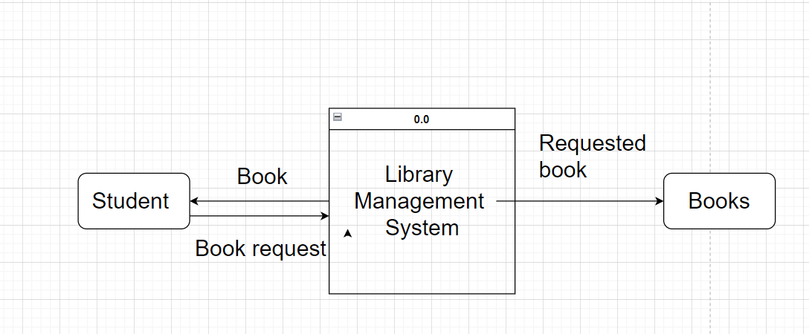

**DLD level 1:**

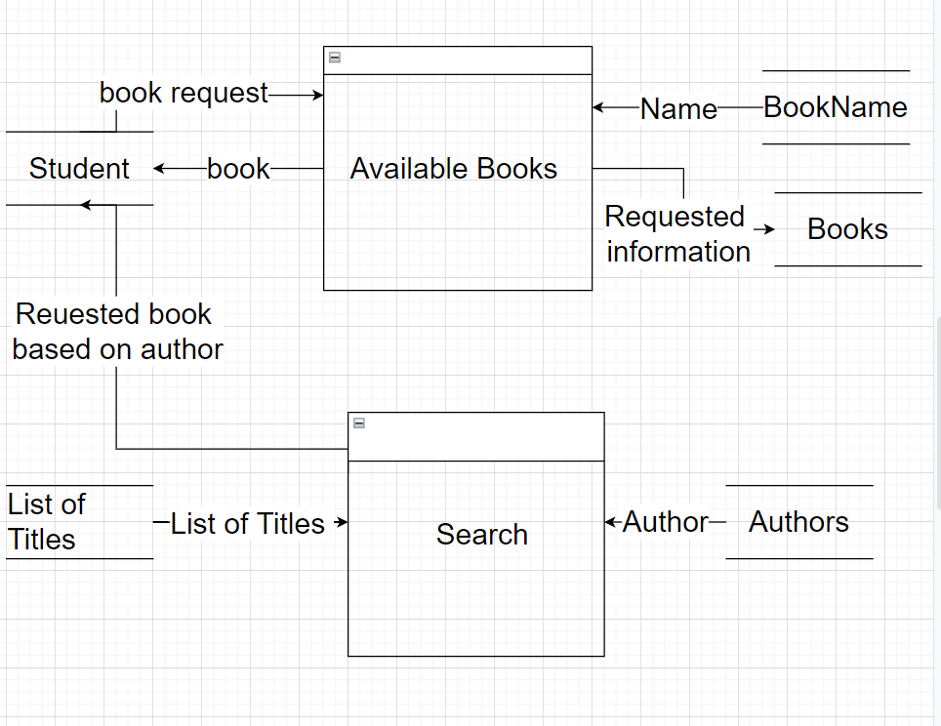

**DLD level 2:**

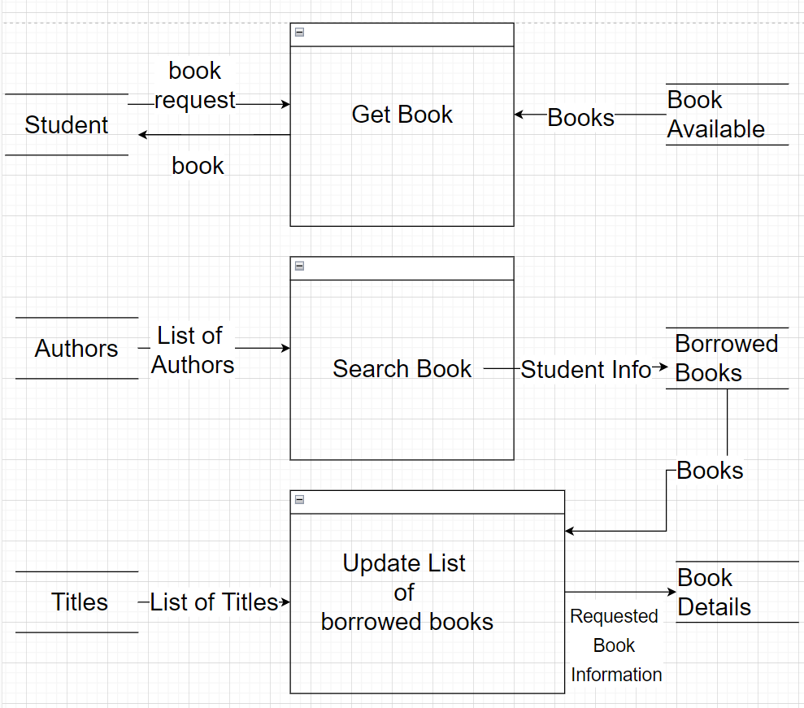

**SCREENSHOTS:**

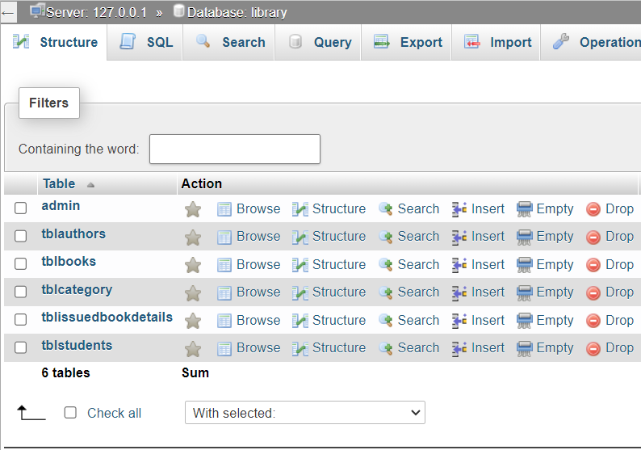List of Tables

